****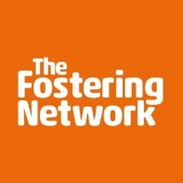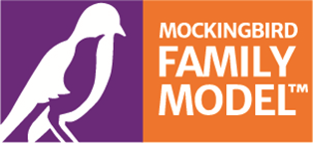

**The Mockingbird Family Model**

**What is Mockingbird?**

North Somerset Fostering Service have been working with The Fostering Network, a national charity for fostering and foster carers, to bring Mockingbird to our children who are looked after and their families. The Mockingbird programme is an exciting and new method of delivering foster care using the Mockingbird Family Model. This is an extended family model that provides sleepovers, day care, peer support, regular joint planning and training, and social activities for children looked after by the local authority and foster carers. The programme improves the stability and retention of fostering placements and strengthens the relationships between carers, children and young people, the fostering service and birth families.

Each family group is known as a constellation and this starts by having a Hub Home, which is an experienced foster carer. The Hub Home carer’s role is to provide support to a group of other foster carer families which are called Satellite Homes. The Hub Home organises meeting, events and get-togethers each month for the children, young people and foster carers within the Constellation. They can also provide planned and emergency sleepovers and day care for children and young people looked after within the Constellation. This means that the children or young people within the Constellation would only ever be looked after by a foster carer they know.

Here is a picture of what the Constellation looks like. The Hub Home carers will be part of the child’s care plan and replicate an extended family.

**Key Roles**

* Hub home carer
* Liaison worker
* 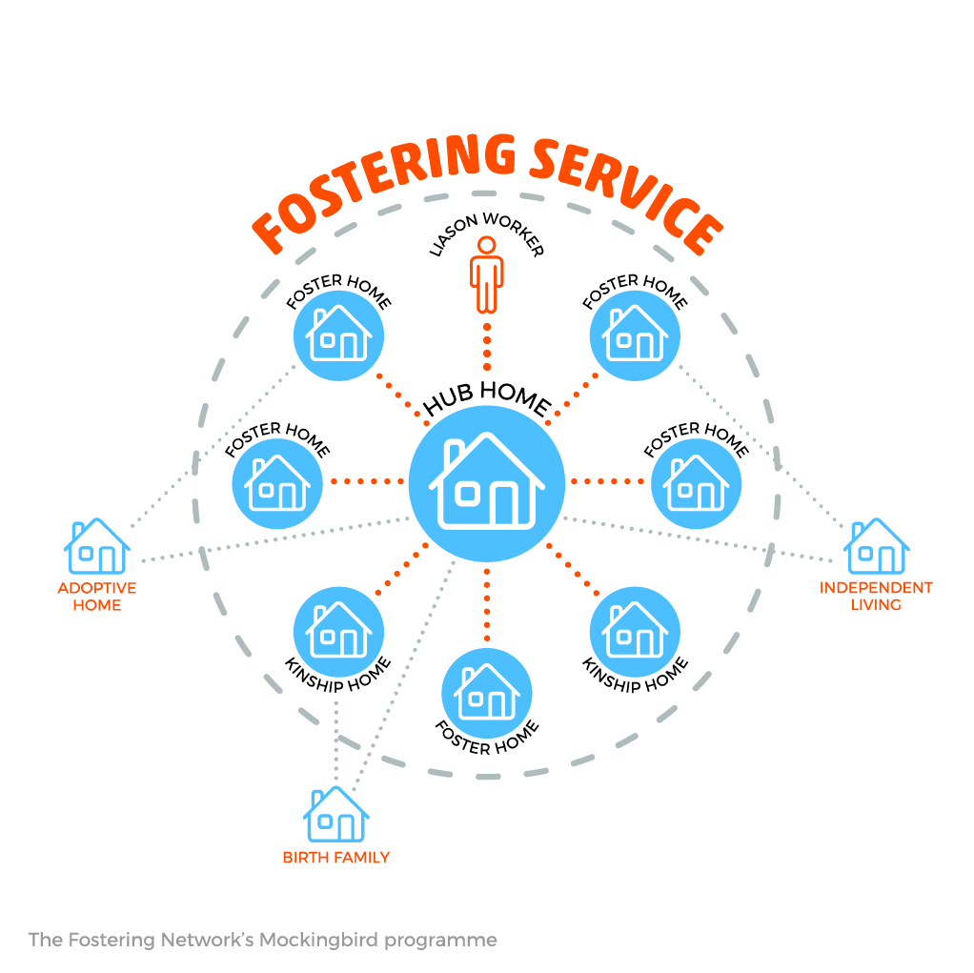Satellite carers

At the heart of the Mockingbird Programme is relationships and communication. Building trusted, strong and authentic relationships between the adults, children and young people within and between each foster family offers each person the support, care and time they may need and replicates an extended family model. It takes a village to raise a child and the Mockingbird Programme provides that village.

**Key elements of the model**

* Foster carer led advice, guidance and emotional and social peer support
* Planned and emergency sleepovers and day care
* Opportunities for children to build friendships and share experiences
* New experiences and opportunities for children to attend events and activities
* Formal and informal training and development opportunities
* Whole community social activities like trips to adventure parks or a BBQ in the park
* Support to help children feel secure and safe in any transition to adoption, change of foster carer or return to family
* Support for children to spend time with brothers and sisters and other birth family

**Mockingbird’s underpinning principles**

* birth family viewed as partners and future support
* helping children to remain living in an area they know
* Keeping in touch with important family members
* Support to maintain relationships and ensure continuous care
* Children are only looked after by someone they know and have a relationship with
* Supporting children to embrace their cultural and religious beliefs and values
* Hub Home carer and Satellite carer share delegated authority
* Support for foster carers, and parents where possible
* Children spending time with other children who are also looked after

**Mockingbird’s impact**

* Children have a reduced number of foster family moves
* Helping foster carers to stay carers for longer
* Children and carers have a network of strong and genuine relationships that replicate support offered by an extended family
* Children are able to spend time with their brothers and sisters
* Children no longer have to stay with unknown families for respite
* Foster carers build new skills and relationships, increasing foster carer satisfaction
* Helping to recruit new foster families
* There is a community of support for times of difficulty, transition and crisis situation.
* Improved relationships between carers and birth family

**Mockingbird Fidelity**

Mockingbird is an evidence-based model supported by clear fidelity criteria. Key components of the Mockingbird fidelity checklist include:

* 6-10 satellite homes in a constellation providing care to 6-18 children looked after
* Hub home has two spare Mockingbird beds available for sleepovers by the constellation
* Hub home carer is available nearly 24/7 and hosts monthly constellation meetings and provides planned and spontaneous opportunities for social events and interactions between the hub home and the satellite families
* The ‘Mockingbird liaison worker’ role is a key support for hub home carer to prevent burnout

For more information contact 01934 421900

[Carrie.Worth@n-somerset.gov.uk](mailto:Carrie.Worth@n-somerset.gov.uk) or [Melissa.Fowler@n-somerset.gov.uk](mailto:Melissa.Fowler@n-somerset.gov.uk)