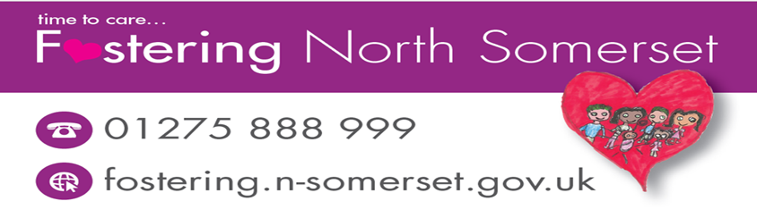

**Recommend a friend to receive up to £1K**

* Payment made for each recommended friend who is approved at Panel



You will receive:

£50 if home visit undertaken

£150 following completion of stage 1 checks

£800 if Carer (s) approved at panel

Foster Carer name:

Date:

**Friend I am recommending…**

**Name:**

**Address:**

**Contact number:**

**Email:**