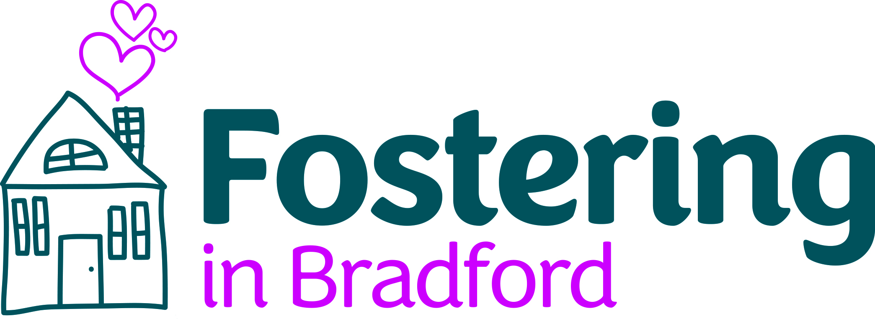



**Mockingbird Hub Home Carer**

**Payment: £27,040** perannum

(£1040 paid fortnightly through allowances)**.**

This is a full time role and includes an additional average of 12 to 16 sleepovers a month. Hub carers must have at least one day off each week and one weekend each month and a maximum of 20 days’ holiday time.

**Hub carers must have two spare beds to be used solely for Mockingbird.**

Foster carers that have children and young people in their care will only be able to apply with the prior written agreement from the child’s social worker and the Supervising Social worker.

**Expressions of interest closing date: 10 February 2023 at 5.00pm**

**Interviews: Late February to suit applicants needs around school holidays.**

**Personal Details:**

|  |  |
| --- | --- |
| Name |  |
| Address |  |
| Telephone |  |
| Email |  |
| Are you applying as a couple or are you a single carer? |  |

**Physical capacity to be hub carer:**

|  |  |
| --- | --- |
| Do you have 2 spare beds? 1 in a spare bedroom and the 2nd in either another spare bedroom or in a sleepover space, with a door that closes (the 2nd bed could be a blow up mattress). |  |

**Skills needed to be considered as hub carer:**

|  |  |
| --- | --- |
| Please provide a brief outline of your fostering experience that you think makes you a suitable candidate for the hub carer role.  (No more than 300 words). | . |
| What other experience do you have that is relevant to the hub carer role?  (No more than 300 words). |  |
| How do you meet the required knowledge and skills required for the post? Refer to the Mockingbird hub home carer role and responsibilities document that can be found in the Facebook group and on [the online handbook](https://www.fosteringhandbook.com/bradford/training.html)  (No more than 300 words). |  |
| How do you meet the personal and physical requirements for the role?  (No more than 300 words). |  |
| Do you have any additional information you want us to know about?  (No more than 100 words). |  |

Please submit all expressions of interest by secure email (Galaxkey) to [Vickie.oldroyd@bradford.gov.uk](mailto:Vickie.oldroyd@bradford.gov.uk)